Architecture document with diagrams
(Title : Voice-First Telugu Government Scheme Agent)

Problem Statement & Objective
1.1 Problem Statement
Accessing government and public welfare schemes remains a major challenge for many citizens in India, especially those living in rural and semi-urban areas. Most existing digital platforms are text-heavy, English-centric, and complex, which creates a barrier for users who are not comfortable with English or advanced digital interfaces.
Many eligible citizens are unaware of:
- Which government schemes they qualify for
- What documents are required
- How to begin the application process
As a result, a significant portion of welfare benefits does not reach the intended beneficiaries.
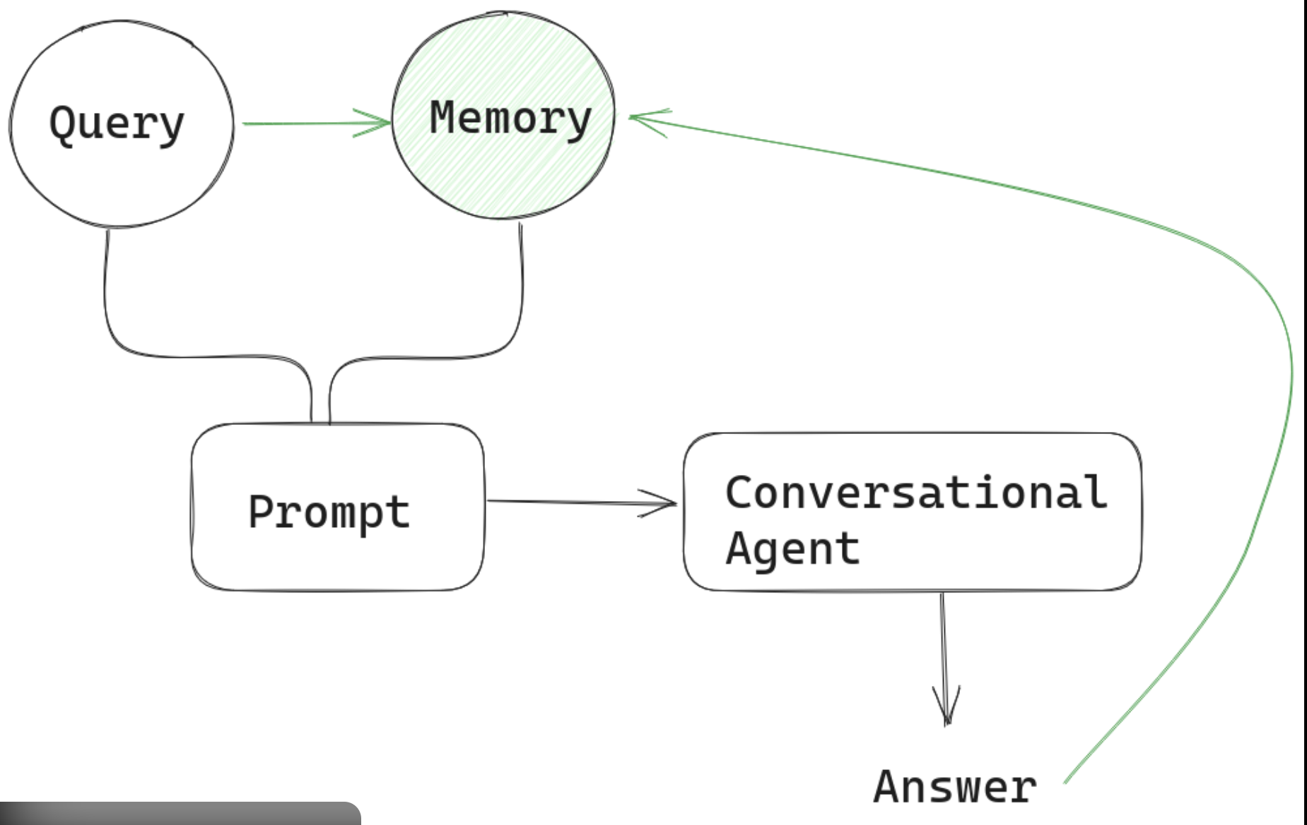

1.2 Why a Voice-First Telugu Agent
India has a large population of native language speakers, and Telugu is one of the most widely spoken regional languages. A voice-first system provides the following advantages:
- Removes literacy and typing barriers
- Enables natural interaction using spoken Telugu
- Makes digital services accessible to first-time users
- Mimics real-world human assistance
By allowing users to speak naturally in Telugu, the system becomes inclusive, intuitive, and user-friendly.

1.3 Objective of the System
The objective of this project is to design and implement a voice-first, agentic AI system that:
- Accepts Telugu voice input
- Understands user intent
- Reasons step by step like a human assistant
- Uses external tools to fetch relevant information
- Maintains conversation memory across turns
- Handles failures safely without hallucination
The system helps users identify suitable government or public welfare schemes and guides them in a structured manner.
System Architecture Diagram
2.1 High-Level Architecture

User Voice
↓
Speech-to-Text (STT)
↓
Planner Agent
↓
Tool 1: Government Scheme Retrieval
Tool 2: Mock Eligibility / Response API
↓
Evaluator
↓
Text-to-Speech (TTS) Output
Diagram:
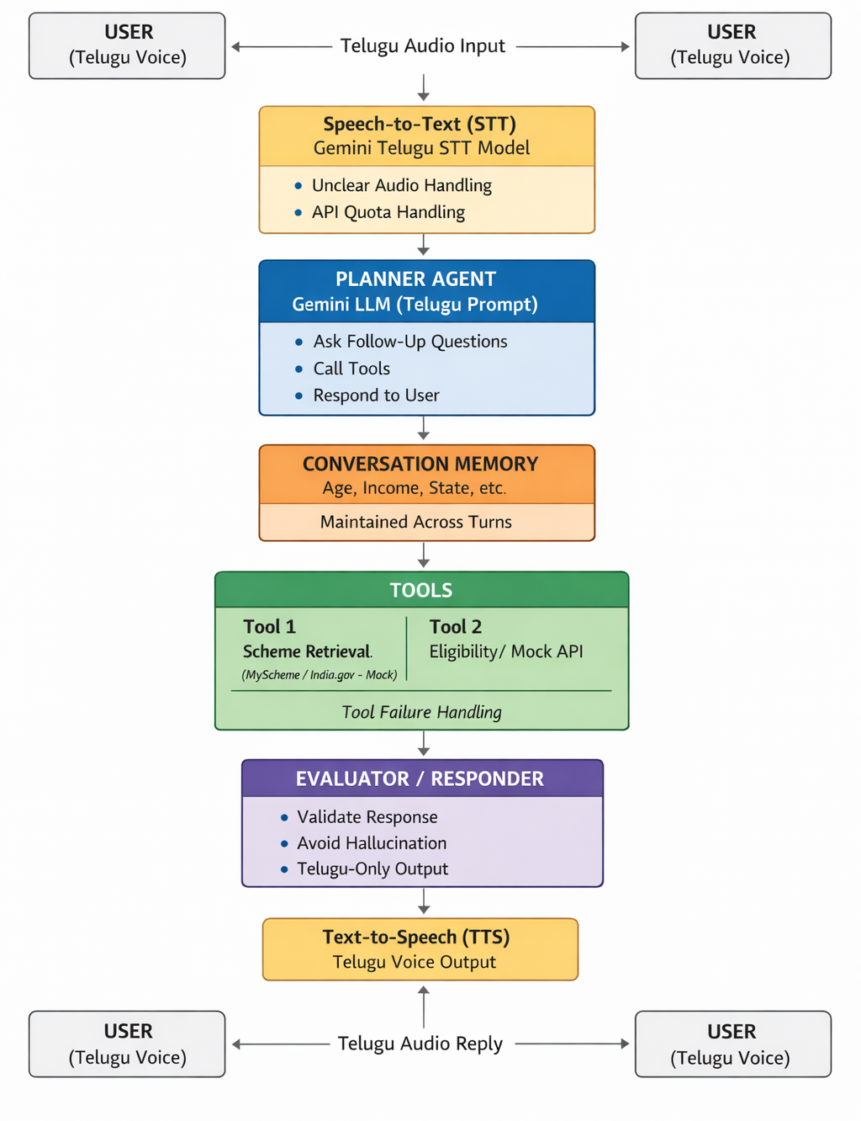
2.2 Component-wise Explanation
User Voice Input
The interaction begins with the user speaking in Telugu. This ensures a natural and accessible interface, especially for non-technical users.
Speech-to-Text (STT)
The STT module converts Telugu audio input into textual form. This text acts as the primary input for reasoning and decision-making.
Planner Agent
The planner agent is the core intelligence of the system. It:
- Interprets the user’s intent
- Determines whether enough information is available
- Decides whether to ask follow-up questions or call tools
This makes the system truly agentic, rather than a single-prompt chatbot.
Tool Layer
Two tools are used:
- Government Scheme Retrieval Tool – fetches information about schemes
- Mock Eligibility / Response API – simulates eligibility checks and guidance
Using tools ensures grounded responses instead of assumptions.
Evaluator
The evaluator checks:
- Whether the tool output is valid
- Whether the response is complete and safe
- Whether any failure handling is required
Text-to-Speech (TTS)
The final response is converted back into Telugu voice, completing the voice-first loop.

Agent Lifecycle & Internal Working
3.1 Planner Logic
The planner agent follows a decision-based workflow:
- Receive transcribed Telugu text
- Identify user intent (scheme inquiry, eligibility check, clarification)
- Check memory for previously stored details
- Decide next action:
  - Ask follow-up question
  - Invoke a tool
  - Provide final response
This ensures structured reasoning instead of static replies.
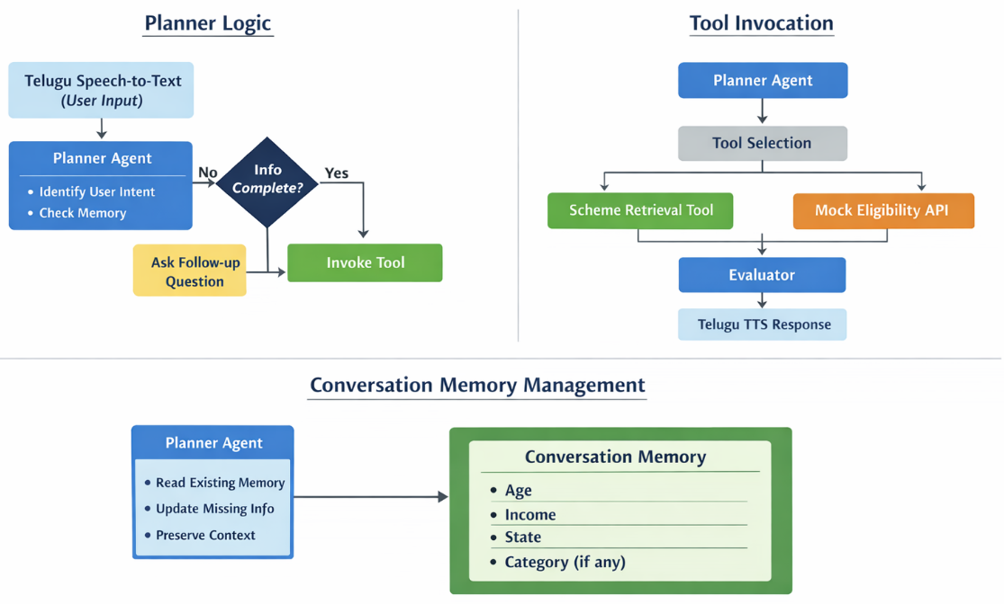
3.2 Tool Invocation Process
Tools are invoked only when required:
- If scheme details are needed → Scheme Retrieval Tool
- If eligibility-like reasoning is needed → Mock API
This separation prevents hallucination and keeps responses grounded in available data.

3.3 Conversation Memory Management
The system maintains memory across turns, such as:
- Age
- Income
- State
- Category (if provided)
Each new interaction updates the memory instead of overwriting it.
This allows the agent to build context gradually, just like a human assistant.

Failure Mechanisms & Recovery
Robust failure handling is a critical part of this system. Instead of crashing or guessing, the agent responds safely.

4.1 Speech-to-Text Failure
Scenario:
- Unclear audio
- Empty or very short transcription
Handling:
- Detects low-confidence or empty STT output
- Politely asks the user to repeat the input
4.2 Missing Information Failure
Scenario:
- User does not provide age, income, or state
Handling:
- Planner detects missing fields
- Asks specific follow-up questions in Telugu
- Continues the conversation without restarting

4.3 Tool Failure
Scenario:
- Tool returns empty or invalid response
Handling:
- Evaluator blocks unsafe output
- Responds with a clear message indicating temporary unavailability

4.4 Quota / API Limit Exceeded
Scenario:
- External API or model quota exceeded
Handling:
- Retry with delay
- Graceful fallback logic
- System continues functioning without abrupt termination

Conclusion
This architecture demonstrates a complete voice-first, agentic AI system that satisfies all assignment requirements.
It combines natural language interaction, structured reasoning, tool usage, memory, and failure handling to create a reliable and inclusive Telugu government scheme assistant.

